CSyllabus

Final Report

Version 0.1

Contents

1. *Introduction* 1

1.1 Purpose of this document 1

1.2 Document organization 1

1.3 Intended Audience 1

1.4 Scope 1

1.5 Definitions and acronyms 1

1.5.1 Definitions 1

1.5.2 Acronyms and abbreviations 2

1.6 References 2

2.1 Deliverables 2

2.2 Requirements document 2

2.3 Possible improvements 2

2.4 Software setup 2

2.5 Code structure 2

3.1 Organization and routines 3

3.2 Metrics 3

3.2.1 Project effort 3

3.2.2 Team metrics 3

3.3 Positive experiences 3

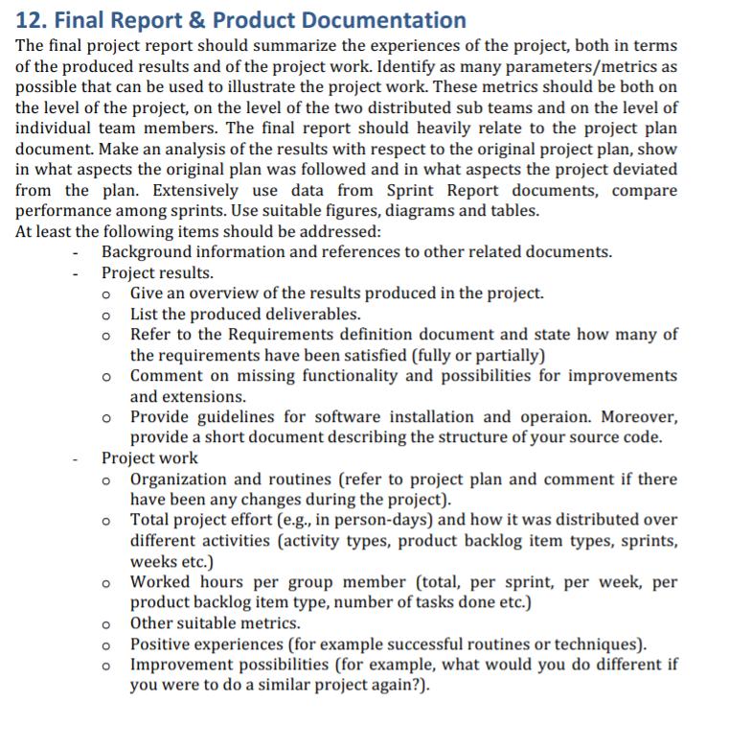

# Introduction

## Purpose of this document

## Document organization

The document is organized as follows:

* Section 1, *Introduction,* describes contents of this guide and provide general information’s for whom and in a what way is this document created
* Section 2, *Project results*
* Section 3, *Project work,*

## Intended Audience

The intended audience is:

* Project team
* Customer
* Product owner

## Scope

## Definitions and acronyms

### Definitions

|  |  |
| --- | --- |
| **Keyword** | **Definitions** |
| FER | Faculty of electrical engineering and computing |
|  |  |

### Acronyms and abbreviations

|  |  |
| --- | --- |
| **Acronym or**  **abbreviation** | **Definitions** |
| **NTR** | Nothing to Report.  There is no available information’s to a specific topic. |

## References

This document refers to the

* Project Plan,
* Requirements and
* Design Description document.

1. Project results

CSyllabus is imagined as a web platform which should ease up process of finding and comparing courses on domestic and foreign faculties. It enables user to discover and compare courses on interactive way through web application. This “one click” app saves time and provides very useful informations to interested parties.

## Deliverables

Project delivers features based on user stories also with technical improvements through time of developing product. Deliverable items in this project are:

* **Collected syllabuses** from 4 countries and 5 universities
  + Croatia: Faculty of electrical engineering and computing
  + Sweden:
  + Italy:
  + United states of America:
* **Created web page** where user can explore and compare courses
  + In explore part user can see what are available courses based on his input
  + In comparator part user can compare his own faculty with some other faculty from the database
* creating secure server-client communication using HTTPS
* **Application publicly visible** by leasing a server and domain:
  + <https://www.csyllabus.com>
* **Bug reporting page** where team members along with other testers can report found bugs
  + <https://bugs.int-rev.com/>
* **CSyllabus plugin** = offers other faculties possibility to include CSyllabus application to their faculty pages. With CSyllabus plugin students can search courses from CSyllabus database.
* **FER plugin** = plugin with CSyllabus Explorer possibility for only FER faculty.
* **User identification** with Facebook and Google account
* **Social course sharing** = users can share his favorite courses with others through
  + Facebook
  + Twitter
  + LinkedIn
  + WhatsApp
* **Admin site** = user with admin privileges can modify existing syllabuses
* **About us page** = page describing what we are doing so common user can easily understand what CSyllabus is all about.
* **Connect (Developer center)** = page with technical information’s where are described technical part of implementation and also listed contact and documentation sources.
* **Mobile view** = web application is fully adapted to mobile view. Content is rearranged based on screen size to enable seamless experience in common usage.

## Requirements document

From initial 18 user stories, 13 was finished. Five user stories were abandoned as become irrelevant or deprecated in project vision. Major features are preserved. Requirement document passed through 10 stages from initial draft to fully implemented document.

## Possible improvements

## Software setup

Software setup consists of setting frontend and backend parts. Both parts can be run individually for debugging process.

**Backend setup guide:**

* install PostgreSQL 9.6x (<https://www.postgresql.org/download/>)
* install with pgAdmin
* create new server hostname -> “localhost”
  + write down password and username for root
  + (usually username = postgres)
  + after installation create a database in pgAdmin to be used with the opensyllabus and write down the name used
  + if you create a new username and password for the database write it down too
* install python 2.7 (<https://www.python.org/downloads/>)
  + check python version in command line with 'python -V'
* install pip for python 2.7 (it already comes shipped with python 2.7.9+)
  + check pip version with *'pip -V'*
* install django with *'pip install django'*
  + check django version with
    - *'python -c "import django*; print(django.get_version())"'

**Install project requirements**

* position yourself in CSyllabus root folder
* pip install -r backend/requirements/devl.pip
* in file backend/settings/devl.py field change DATABASES according to database name, username and password you wrote down in first

**Steps for migrating and loading data**

* *python manage.py migrate*
* *python manage.py loadtestdata users.EmailUser:100*
* *python manage.py loaddata backend/apps/csyllabusapi/fixtures/fer_fixtures_json.json*
* *python manage.py loaddata backend/apps/csyllabusapi/fixtures/laquila_fixtures_json.json*
* *python manage.py loaddata backend/apps/csyllabusapi/fixtures/mockup_fixtures_json.json*
* *python manage.py createsuperuser*

**Running backend with command:**

* *python manage.py runserver*

**Frontend setup guide:**

* install nodeJS (<https://nodejs.org/en/download/>)
* position youself in the frontend/csyllabus folder
* run *‘npm install’*
* serve angular app with *‘ng serve’*

## Code structure

1. Project work

## Organization and routines

## Metrics

### Project effort

### Team metrics

#### Italy

#### Croatia

#### Individual team members

## Positive experiences